**How to remove audio and make videos smaller using Handbrake with a few easy steps.**

[Download](https://handbrake.fr/) and Install.

**STEP 1 - Start Handbrake and click on File (Open a single video file):**  
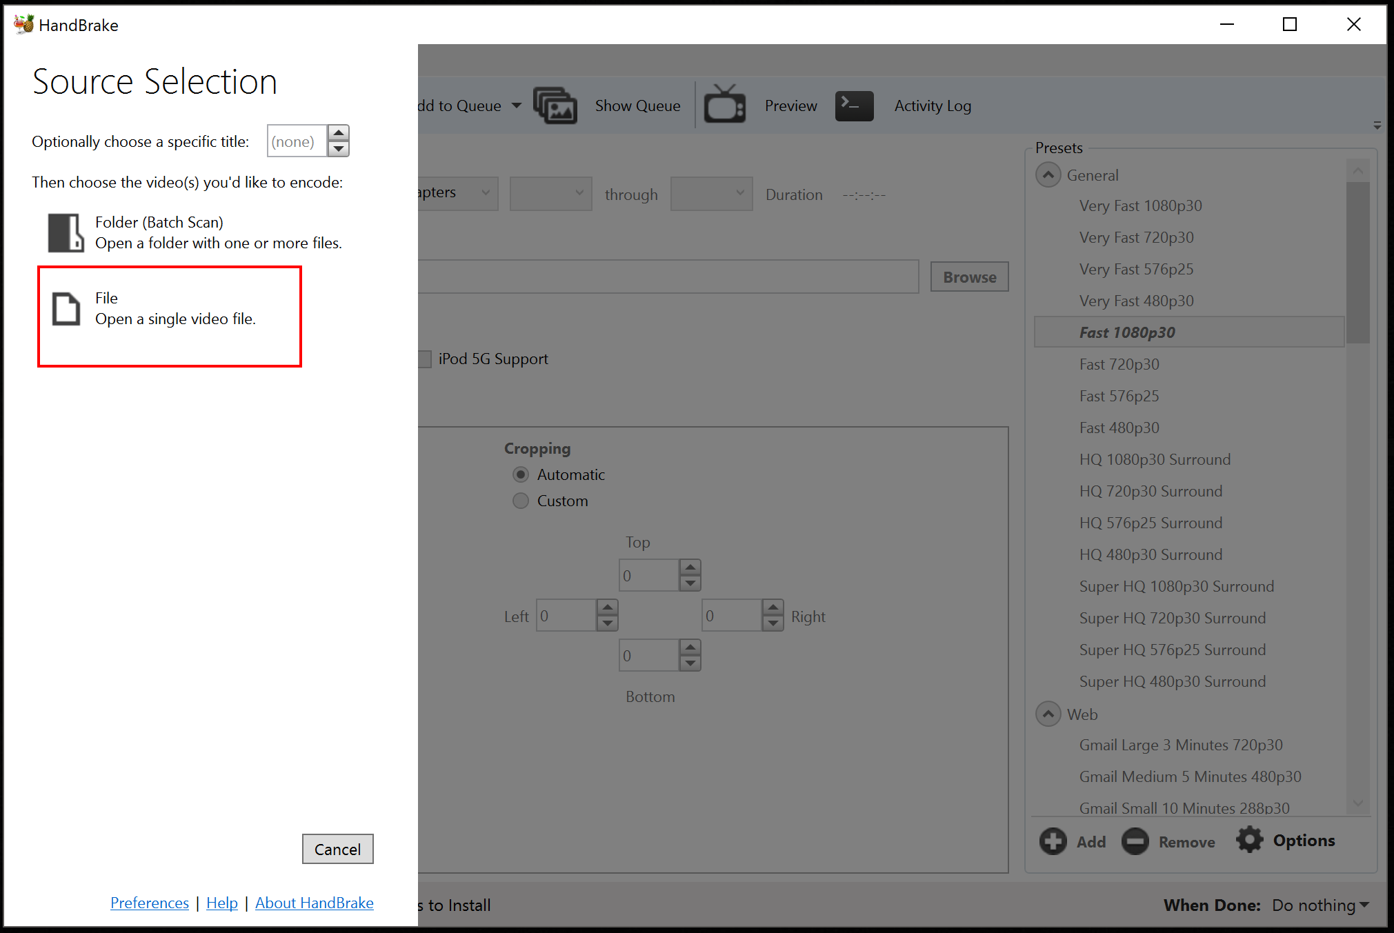

**Now that we have added the video, we are now ready to cut it and/or remove the sound.**

**STEP 2 - Next step is to set the destination file name and location (I set the location to Desktop and filename as Video.mp4):**

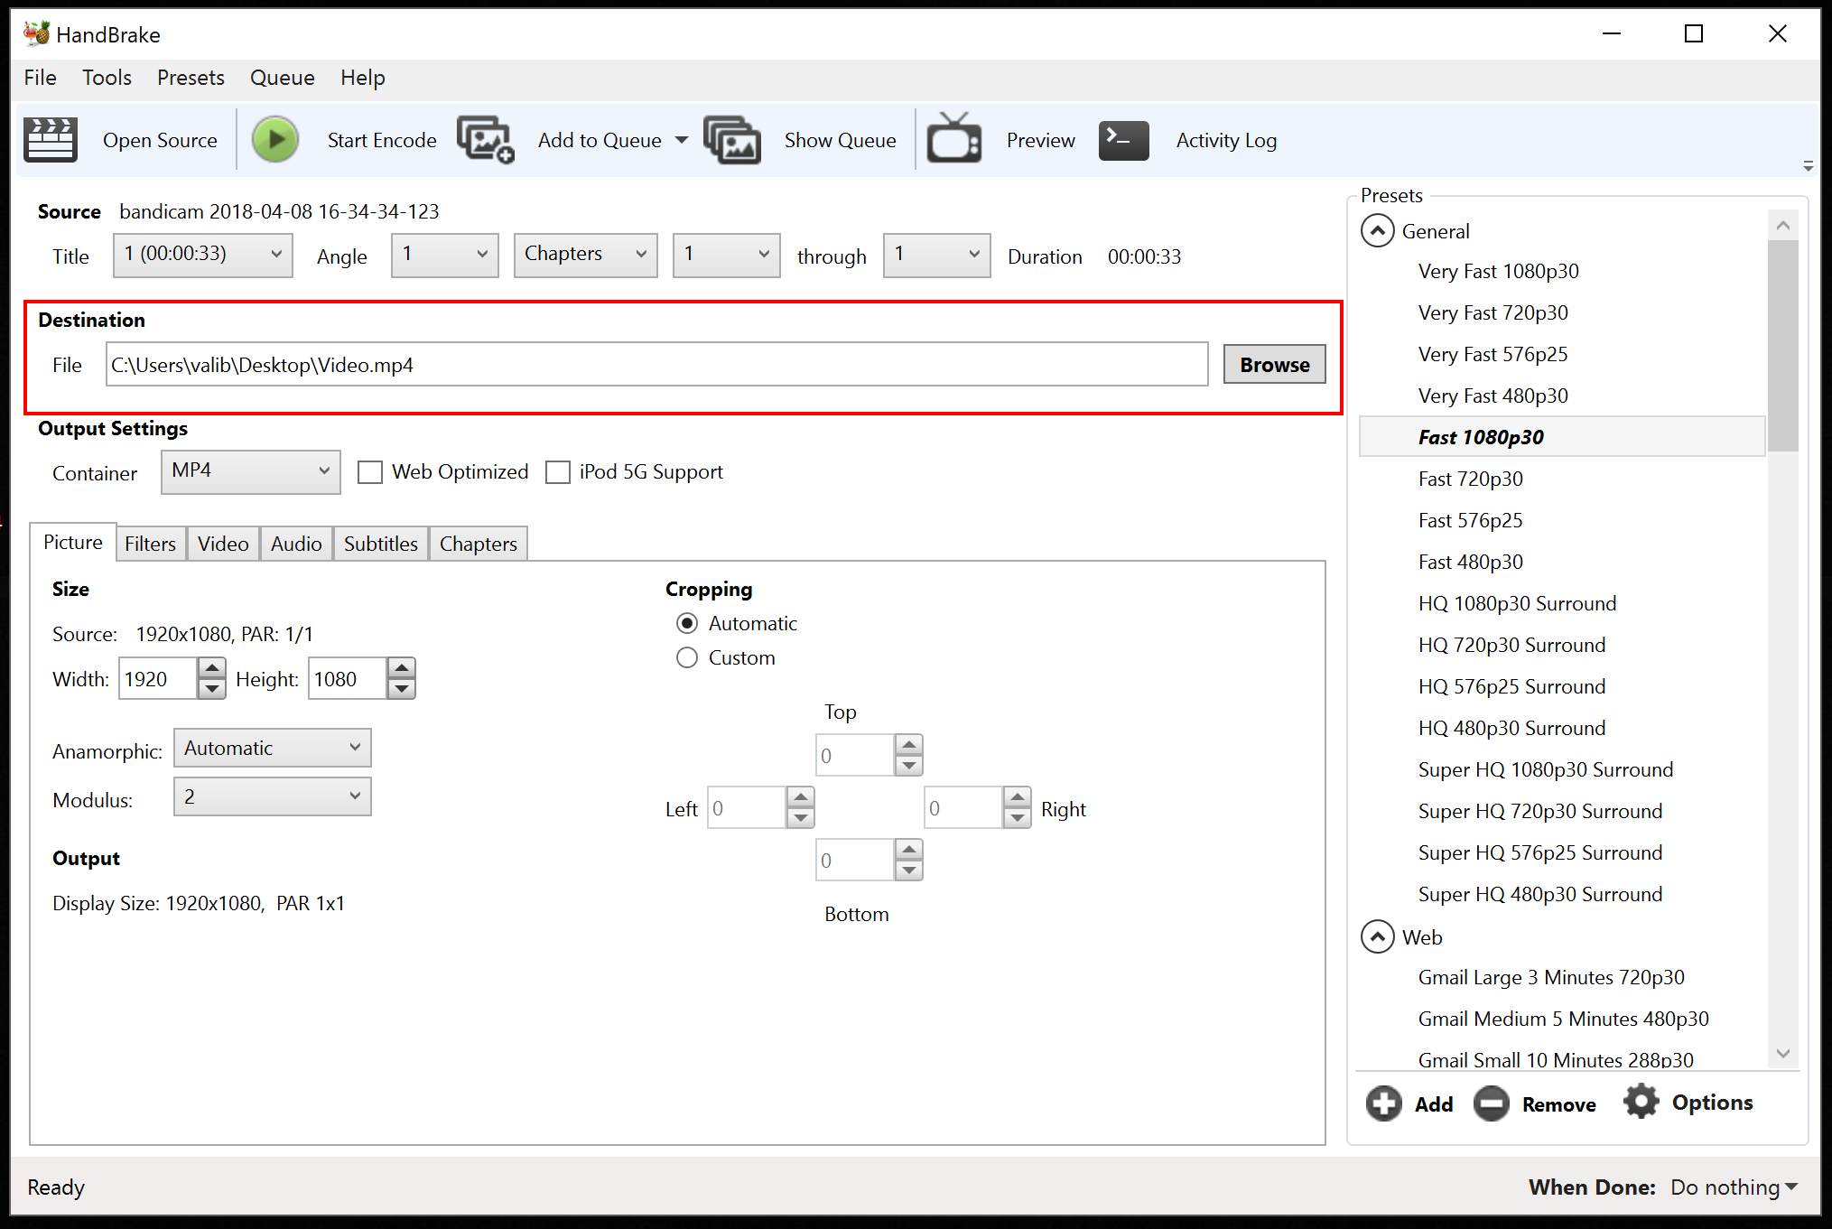

**STEP 3 - Next we select the preset type and prepare the video for Encoding:**

**Let’s say we have a 50Mb Video with sound and we need to make it smaller and remove the background audio.**

*Handbrake has tens of Presets to be used when needing to cut the video or make it smaller. I will use a basic General preset in this tutorial:* ***Fast 720p30****. This will shorten my video’s size to about* ***30%*** *of its initial size.*

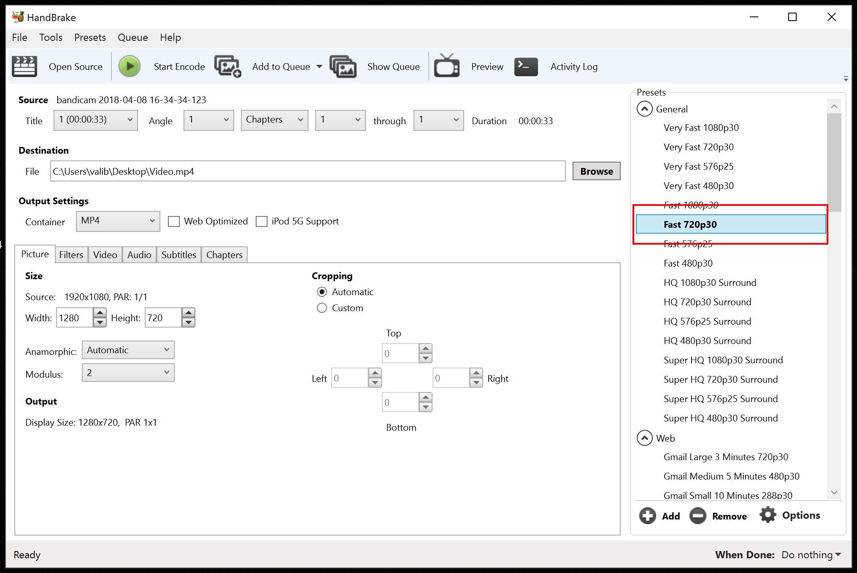

**STEP 4 (optional) - IF we need to remove the audio track from the video (mute video):**

In order to remove the audio track from the video, tap on Audio tab from Output Settings and click on Clear or the X button next to the audio track:

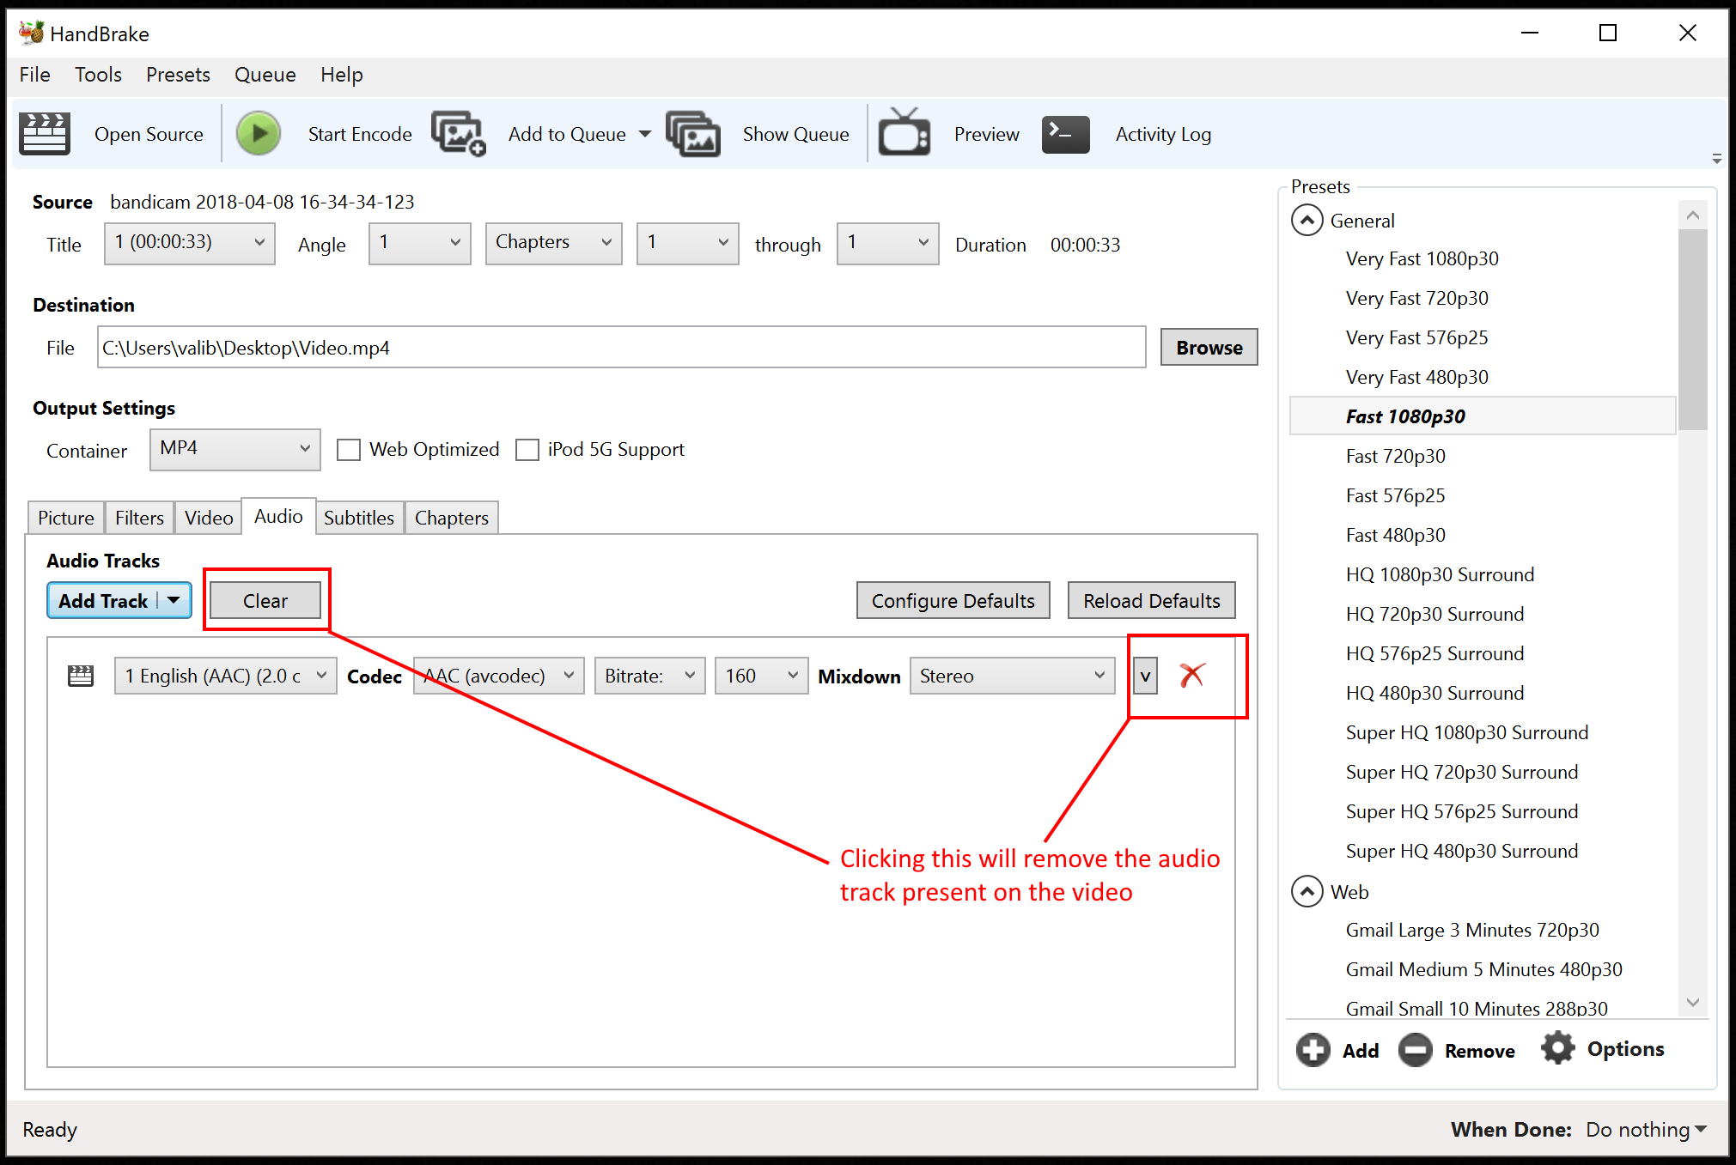

**STEP 5 - Start Encode – this will encode the video and save it in the location set on 1st step:**

Once I have removed the audio and selected my desired/needed preset, I can now start the Encoding process and my video will be shorten and audio removed:

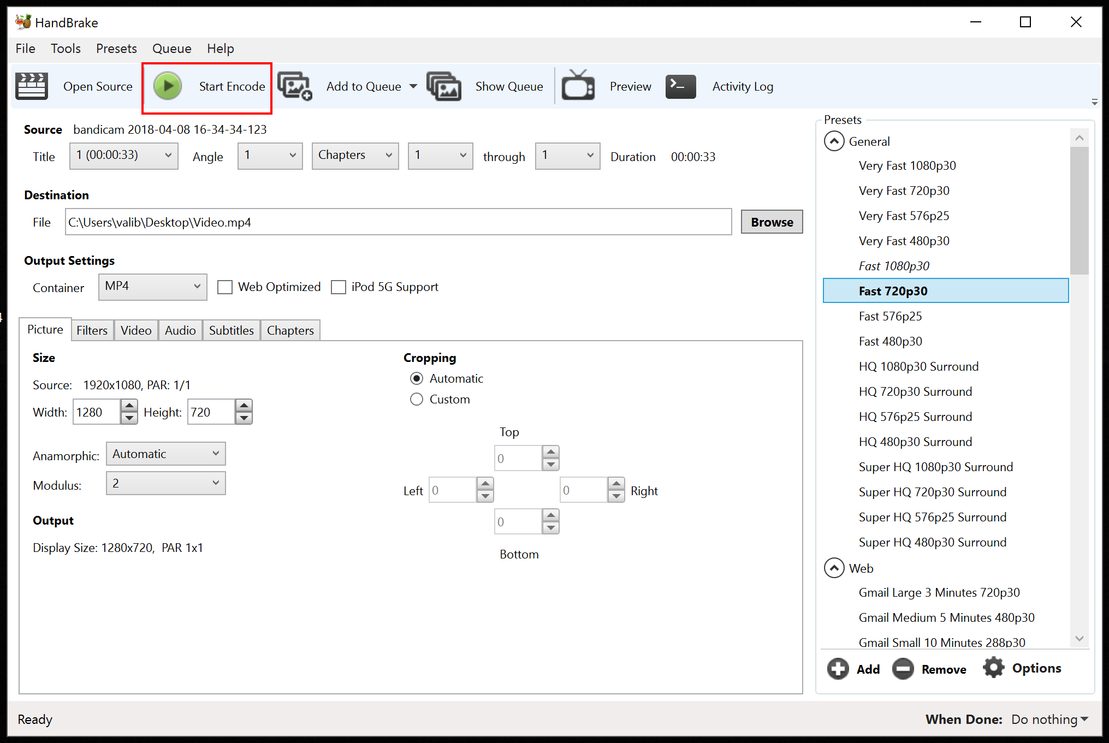

When finished, my once 50Mb video just turned into something way smaller than that, somewhere between 10-15Mb and of course, the sound is no longer there.